West Yorkshire Area Team
2014/15 Patient Participation Enhanced Service – Reporting Template

Practice Name: Newland Surgery

Practice Code: B87033

Signed on behalf of practice: J. slam Date:30/3/15

Signed on behalf of PPG: Cynthia Sykes Date: 30/3/15

- Prerequisite of Enhanced Service – Develop/Maintain a Patient Participation Group (PPG)

Does the Practice have a PPG? YES

Method of engagement with PPG: Face to face, Email, Other (please specify) Face to Face and Email

Number of members of PPG: 10

Detail the gender mix of practice population and PPG:  % Male Female  Practice 1936 1801  PRG 4 6 | Detail of age mix of practice population and PPG:  % <16 17-24 25-34 35-44 45-54 55-64 65-74 > 75  Practice 628 371 478 457 601 511 393 301  PRG 0 0 0 1 1 3 4 1
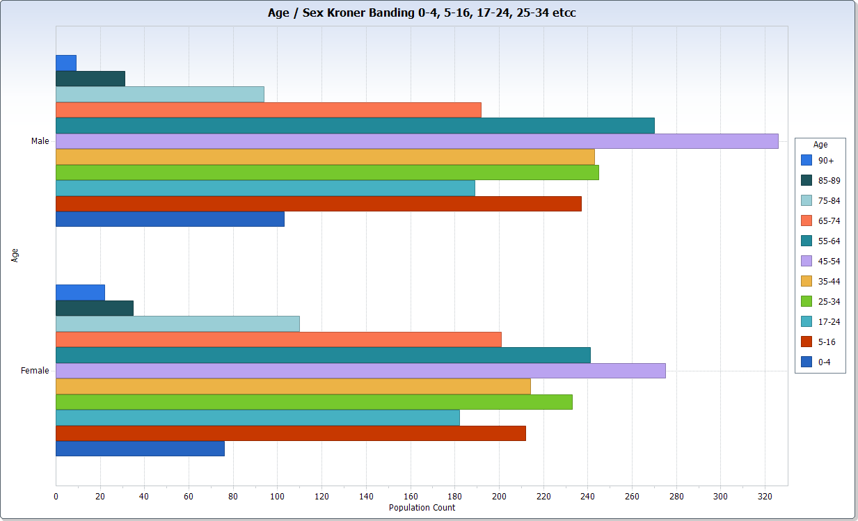

Detail the ethnic background of your practice population and PRG:

 | White |  |  |  | Mixed/ multiple ethnic groups
 | British | Irish | Gypsy or Irish traveller | Other white | White &black Caribbean | White &black African | White &Asian | Other mixed
Practice | 2063 | 5 |  | 81 |  | 4 | 2 | 4
PRG | 10 | 0 | 0 | 0 | 0 | 0 | 0 | 0

 | Asian/Asian British |  |  |  |  | Black/African/Caribbean/Black British |  |  | Other
 | Indian | Pakistani | Bangladeshi | Chinese | Other  Asian | African | Caribbean | Other Black | Arab | Any other
Practice | 12 | 6 |  | 18 | 9 | 12 |  |  |  | 36
PRG | 0 | 0 | 0 | 0 | 0 | 0 | 0 | 0 | 0 | 0

Describe steps taken to ensure that the PPG is representative of the practice population in terms of gender, age and ethnic background and other members of the practice population:

There is substantial variation between the group and the practice profile. The practice has been trying extensively to recruit new members. We have used a variety of methods to recruit and are still continuing to advertise and recruit more members.

The practice has tried to ensure the PPG is representative using the following methods:

Posters displayed around the surgery
Doctors requesting patients during consultation
Nurses requesting patients during consultation
Midwife : requesting mothers to be, during antenatal clinics
Local Parent Craft & Mums & Tots Group ; Practice Midwife Given PRG posters to display on notice board.
Health Visitor has been requested to try and see if she can encourage mothers with children
Link on practice website encouraging patients
Receptionists asking patients directly
Posters requesting patients to join the group virtually has also been displayed.
Recruitment question regarding PPG in survey questionnaire

Are there any specific characteristics of your practice population which means that other groups should be included in the PPG?
e.g. a large student population, significant number of jobseekers, large numbers of nursing homes, or a LGBT community? YES

The practice does not have any PPG members under the age of 35 on the group at the moment.

If you have answered yes, please outline measures taken to include those specific groups and whether those measures were successful:

The practice has tried to encourage younger patients of the practice population to join the PPG by;

Doctors requesting patients to join PPG during consultation
Nurses requesting patients to join PPG during consultation
Midwife : requesting mothers to be, during antenatal clinics
Receptionists asking patients directly
Recruitment question regarding PPG in survey questionnaire

The practice had successfully recruited one patient under the age of 25 but the patient is no longer registered at the practice.

- Review of patient feedback

Outline the sources of feedback that were reviewed during the year:

Any Comments/Compliments/Suggestions received in the Suggestion box

Review of Complaints to identify any themes

Practice national Survey

Practice specific survey

Specific Issues raised by Practice staff

How frequently were these reviewed with the PRG?

Some were reviewed at every PRG meeting and others as and when necessary.

- Action plan priority areas and implementation

Priority area 1
Description of priority area:

To look at the option of texting patients to remind them about appointment times and to provide other patient related information.

What actions were taken to address the priority?

The practice is ready to implement the texting feature but subsequently NHS England announced that the free texting service that is available to practices will not be available any more as of 31st March 2015. This has been extended until the end of September 2015 until local CCGs decide on funding options for the future.

The practice will look at the options available in due course to determine the way forward once the CCG has clarified on funding options later in the year.

Result of actions and impact on patients and carers (including how publicised):

The above action point has not been implemented due to the above issue at the moment. The PRG group would like to carry this action point forward for next year.

Priority area 2
Description of priority area:

To obtain more specific feedback from patients with regards to the problems patients are experiencing with the request and collection of repeat medication.

What actions were taken to address the priority?

Practice specific survey question developed by PRG regarding identifying repeat prescription problems patients are experiencing.
Survey forms collected from patients and reviewed.

Result of actions and impact on patients and carers (including how publicised):

Survey results regarding repeat prescriptions did not highlight any specific problem areas that patients are experiencing.

The practice has increased the number of days before a patient can request repeat medication in advance of due date upto 10 days. This is to allow more flexibility to patients and to reduce the number of rejected script requests because they have been requested early.

Priority area 3
Description of priority area:

To look at the options to provide an Ultrasound Scan Clinic at the surgery. This will be an additional service, which will benefit our patients as they will be able to have a Ultrasound scan closer to home.

What actions were taken to address the priority?

Ultrasound providers in the area contacted to discuss feasibility option of provision of Ultrasound Clinic within our own practice.
Meetings held with Ultrasound provider
Inspection of surgery by provider.
Dates/times and room treatment room availability discussed with Ultrasound provider

Result of actions and impact on patients and carers (including how publicised):

Ultrasound Clinic at Newland Surgery has commenced.
Patients satisfied with Scan undertaken locally closer to home
Practice GPs referring patients into the Service

Progress on previous years

If you have participated in this scheme for more than one year, outline progress made on issues raised in the previous year(s):

Telephone Access
The practice now allows ease of access to patients to speak to a doctor or nurse on the telephone : -

Refresher training given to all staff with regards to the above and the survey results show an improvement of 4% from previous year.

Urgent On Day Appointments
The surgery already offers on the day urgent appointments to all its patients however the patient survey highlighted that patients were having difficulty : -

Refresher training completed for all our reception staff to ensure that all patients requesting urgent on the day appointments are seen the same day.
Survey result show a 1.8% improvement compared to previous year.

Appointments Online
The practice to offer patients the ability to book appointments online. Post migration to new clinical system - EMIS web

The practice now offers patients the option to book appointments online although the take up has been slow.

- PPG Sign Off

Report signed off by PPG: YES

Date of sign off: 30th March 2015

How has the practice engaged with the PPG:

The practice holds PRG meetings every two to three months and also communicates with its members via email.
PRG Meetings are held at Newland Surgery.

How has the practice made efforts to engage with seldom heard groups in the practice population?

Patients in seldom heard groups have been approached directly but the practice has not been successful in attracting specific members i.e. mothers to be, young adults or teenagers etc..

Has the practice received patient and carer feedback from a variety of sources?
Yes – complaints, comments, suggestions, direct feedback and practice surveys

Was the PPG involved in the agreement of priority areas and the resulting action plan?

Yes the PRG group has agreed the priority areas and action plan

How has the service offered to patients and carers improved as a result of the implementation of the action plan?

Yes as detailed above in priority areas.

Do you have any other comments about the PPG or practice in relation to this area of work?

The practice would like the PRG to be more representative of the practice population but is finding this to be difficult to achieve.

